Name: Vishnu Ram
Email: vishnuram1896@gmail.com
Github:

Assignment 1: Automated Instance Management Using AWS Lambda and Boto3
Objective: Automatically start and stop EC2 instances based on tags using AWS Lambda and Boto3.

1. EC2 Instance Setup
- Launch two EC2 instances.
- Tag first instance: Action = Auto-Stop.
- Tag second instance: Action = Auto-Start.
- Screenshot: EC2 instances and tags.
- 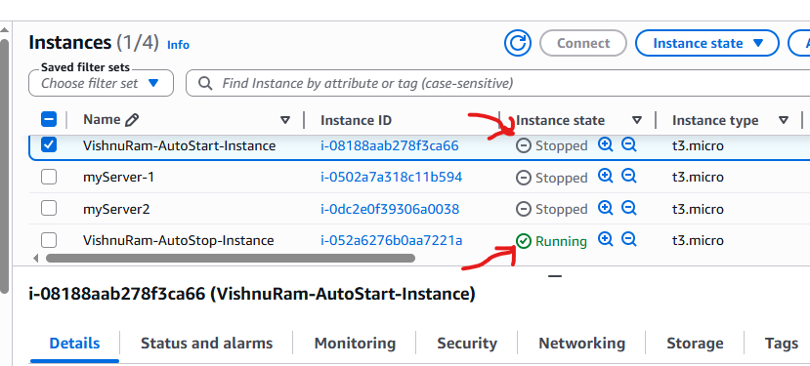

2. Create IAM Role
- Create IAM Role for Lambda.
- Attach AmazonEC2FullAccess policy.
- AWSLambdaBasicExecutionRole.
- Screenshot: IAM Role.
- 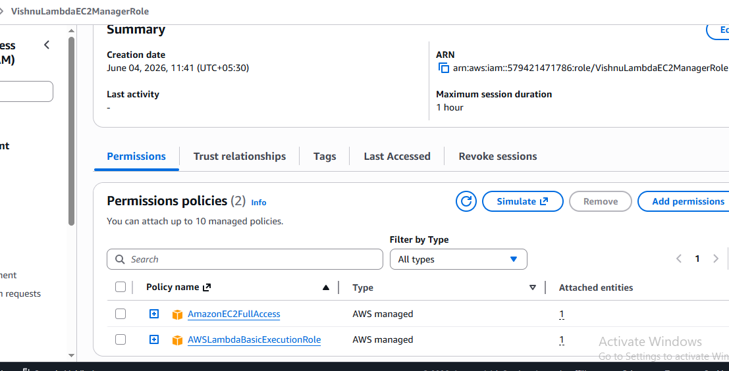

3. Create Lambda Function
- Create Lambda function using Python runtime.
- Assign IAM Role.
- Screenshot: Lambda configuration.
- 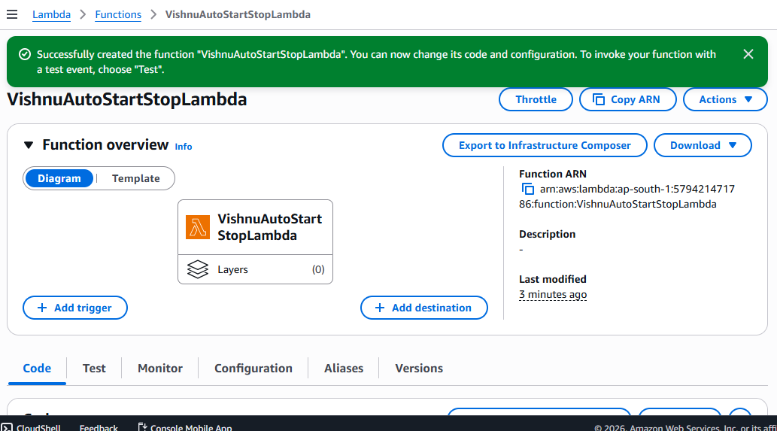

4. Add Python Code
- Paste Boto3 code for Auto-Start and Auto-Stop.
- Deploy the function.
- Screenshot: Lambda code.
- 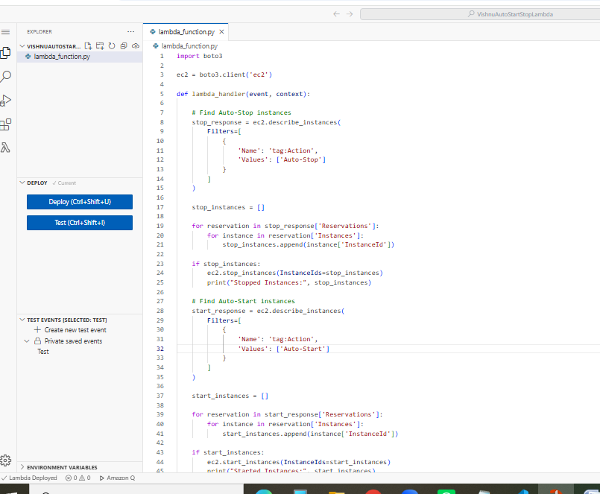

5. Testing
- Create test event.
- Run Lambda function.
- Verify CloudWatch logs.
- Screenshot: Test results.
- 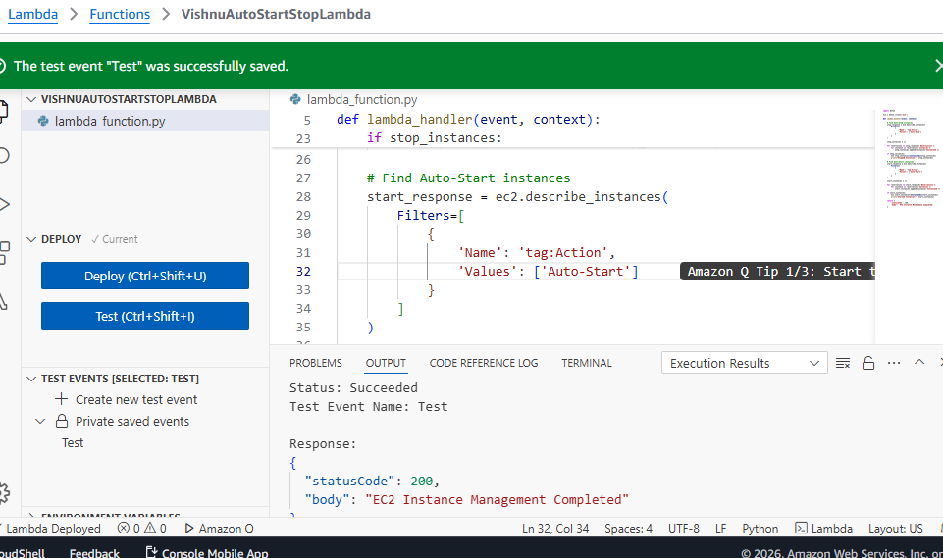

6. Validation
- Verify Auto-Stop instance stopped.
- Verify Auto-Start instance running.
- Screenshot: Final EC2 state after change.
- 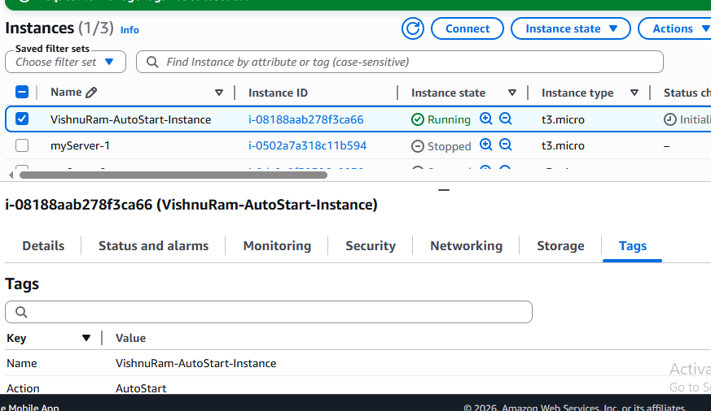
- 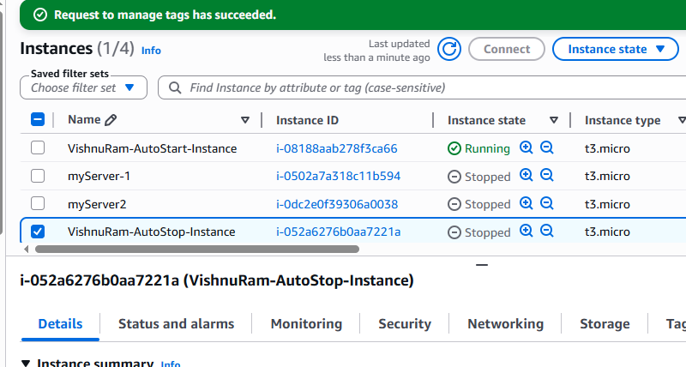

7. Conclusion
- Successfully automated EC2 instance management using AWS Lambda and Boto3.

Screenshot Placeholders

Screenshot 1
Paste your screenshot here.

Screenshot 2
Paste your screenshot here.

Screenshot 3
Paste your screenshot here.

Screenshot 4
Paste your screenshot here.

Screenshot 5
Paste your screenshot here.

Screenshot 6
Paste your screenshot here.

Screenshot 7
Paste your screenshot here.

